September 1st, 2022

To Whom it May Concern,

is a non-profit Volleyball Club in registered with Sask Volleyball, who provides competitive opportunities for youth to play the sport of volleyball. Please note that the following individual is a registered volunteer to coach youth volleyball in this club for the period September 1st, 2022 to August 31st, 2023.

Sask Volleyball, as part of its Screening Policy, requires its coaches to successfully complete a Policy Records Check prior to beginning activity. Please consider this as an application for the individual(s) named above to have the applicable charges for the check waived.

The requested information includes:
- Criminal Convictions
- Outstanding Charges
- Pardoned Sex Offenses listed under the Schedule of the Criminal Records Act.

Information obtained will be treated in the strictest of confidence. We request your cooperation and ask for the reports to be send to:

Sask Volleyball
Attention: Executive Director
1750 McAra Street
Regina, SK S4N 6L4

If you require any other information regarding the Sask Volleyball Screening Policy, please contact Sask Volleyball at 306-535-9231.

Regards,

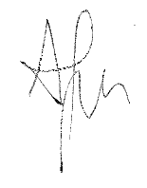

Aaron Demyen
Executive Director
Sask Volleyball

